Marek Titien Olszewski (Poland), 59 years old.

I was born and brought up in a town situated 140 km north from Warsaw, in Poland, and then studied Classical Archaeology (Department of History), Art History and Philosophy at Warsaw and Paris, taking my doctorate from University of Sorbonne in 1998. I am married with one child. After a research fellowship, for study at University of Sorbonne, I taught the Classical archaeology and history of Greek and Roman mosaic at the Institute of Archaeology of the University of Warsaw for 20 years as a Lecturer and Reader. I was research fellow of the Ecole Française d'Athènes, Fondation Hardt at Vendeuvre, Casa Velasquez at Madrid, Ecole Française de Rome and then I was Mellon Post-Doc Fellow at the American School of Classical Studies at Athens (ASCSA) and Albright Institute of Archaeological Research (AIAR) in 2004 and 2005. I participated or conducted the archaeological excavations on thirty historical sites around the Mediterranean See (Nea Paphos, Rome-Palatino, Palmyra, etc). Many years I have been attached to CNRS (J.-M. Dentzer). I have been a visiting scholar at the University of Barcelona, Paris, Catagna, Padua and others. I am attached member of ASCSA and of AIAR. I was elected twice as a Supplement Member of the administrative Council of AIEMA in 2014-2018, and 2019-2024, and as a Member of the Roster of Experts of the Emergency Safeguarding of the Syrian Cultural Heritage Project by UNESCO in 2017. I serve on the scientific editorial boards of a number of Journals (Bulletin de l’Association Internationale pour l’Etude de la Mosaïque Antique, Eikon Imago, De Medio Aevo, Journal of Mosaic Research) . Since 2016 I have been engaged on the Protection of Archaeological Heritage in Syria and particularly on the protection of the Greek, Roman, Byzantine and Arab mosaics, many was stolen. My main interest is the mosaic art and craft, part of sublime or banal artistic and artistry craft of the Roman Empire, broadly conceived to include Hellenistic Period and late Antiquity. I began my researches by looking at the way art was viewed in antiquity by the owners of the villae and domus and the invited guests. To understand not our, contemporary point of view but to take of their attitude, and this has led to an interest in all kinds of reception from the literary description of art to the no direct literary sources. To study the mosaics, for thirty five years I try to use all kind of material sources from archaeological sources to philosophical, rhetorical and historical data. I extend a worm welcome to the scolars and the students to consult my publications (pdf) on the mosaics analyzed in their context (in English, French, Italian or Polish) on academia.edu. (https://www.academia.edu/38354542 ). I would like to mention my just recent articles on the Syrian Cultural Heritage (2017 and 2018, 2021; stolen mosaics; see for ex. : https://archaeologynewsnetwork.blogspot.com/2019/08/photos-of-looted-mosaics-help-pinpoint.html#LSShfyIkDYvADJoU.97), and another one, just finished,monographic, on the antithesis - the figure of rhetoric practiced in visual arts and particularly in the mosaics of Pompeii, Shahba, Antioch, Nea Paphos and Apamea and many others ancient cities ‘Les figures de rhétorique et l’antithèse dans la narration allégorique de la mosaïque de la Maison d’Aiôn à Paphos (Chypre)’, (in:) Ex Oriente Lux. Studies in Honour of J. Młynarczyk ed. by K. Jakubiak, A. Łajtar, Warsaw 2020, pp. 221-250.
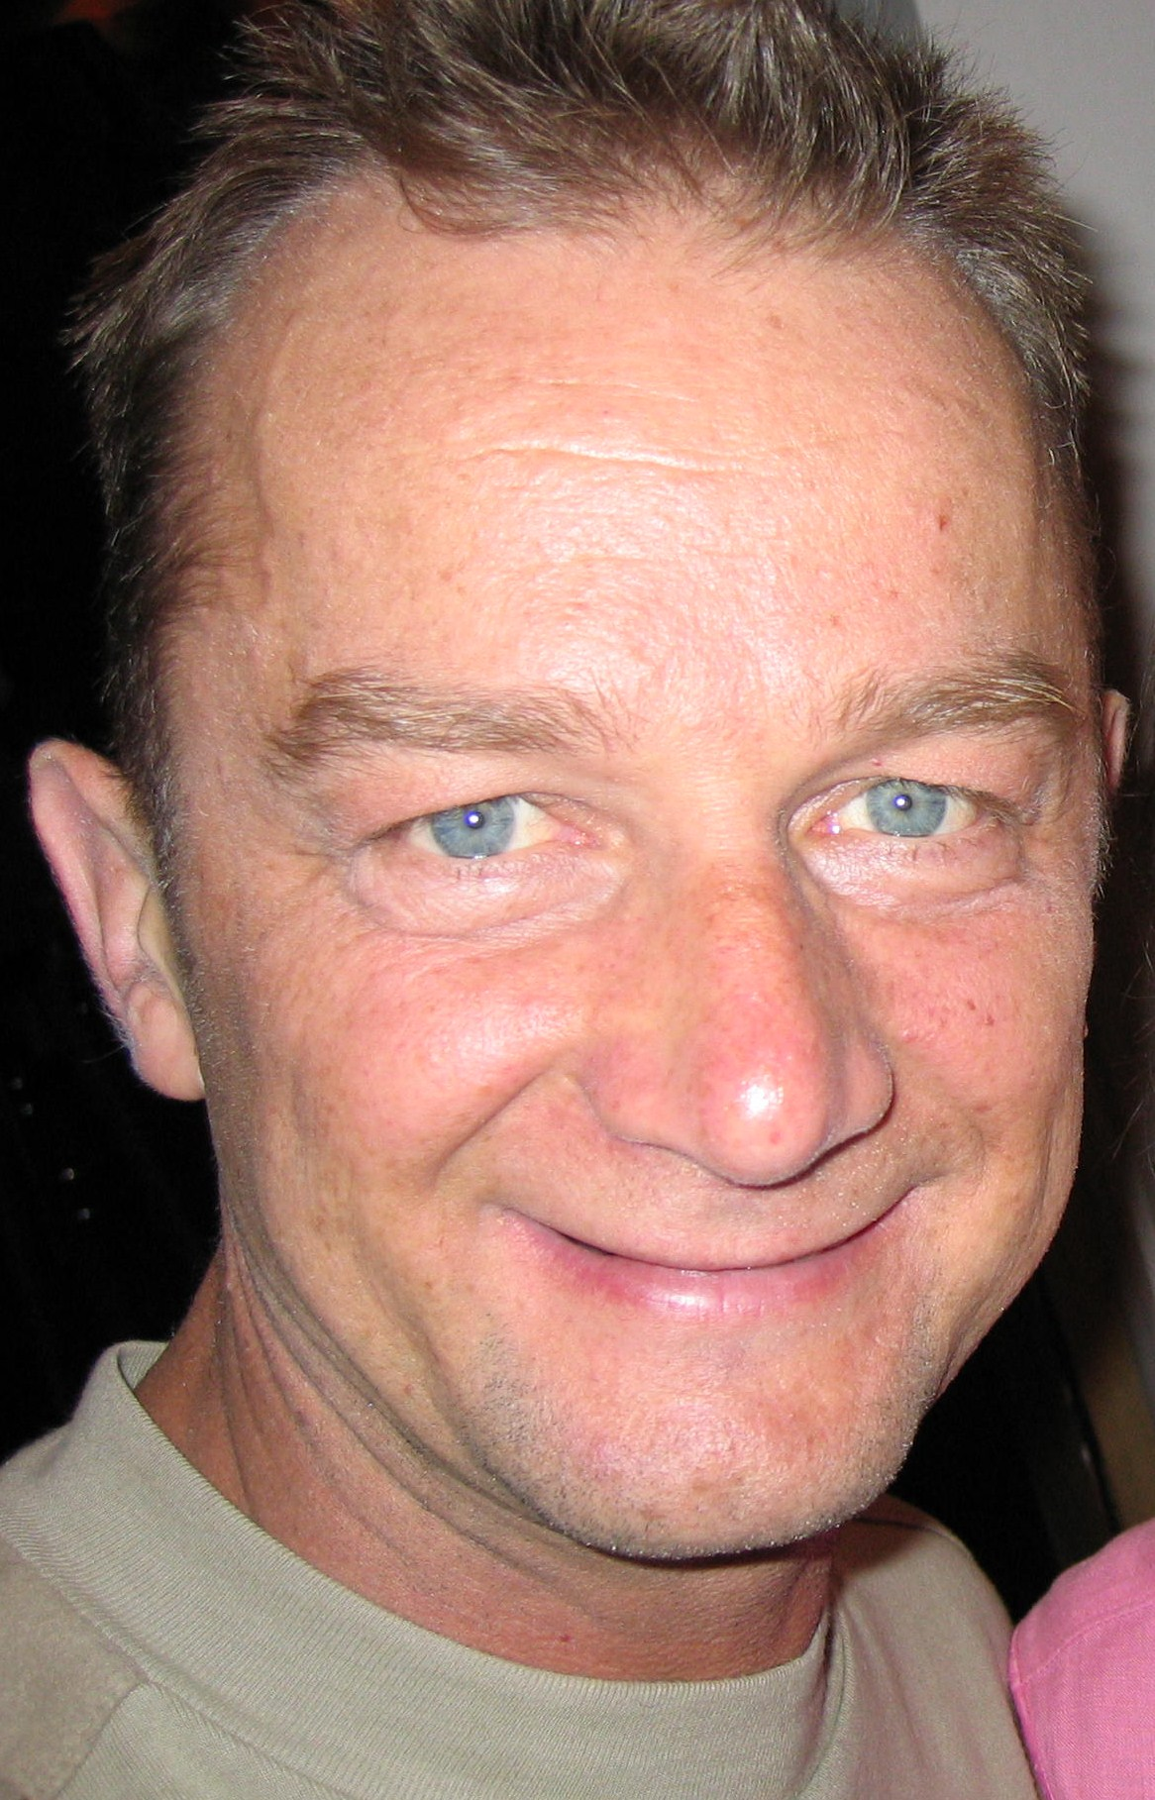

Marek T. Olszewski
PhD with “habilitation”
University of Warsaw
Faculty of Archaeology
Department of Classical Archaeology
ul. Krakowskie Przedmiescie 26/28
00-927 Warsaw
Poland
+48225522809
m.t.olszewski@uw.edu.pl
https://uw.academia.edu/MarekTitienOlszewski

